**Wireframe Document**

**Excel Case Study Data Analysis**

**Revision Number - 1.2**

**Last Date of Revision - 16/10/2022**

**Yash Mirge**

WIREFRAME DOCUMENT DESIGN

**Document Control**

|  |  |  |  |
| --- | --- | --- | --- |
| **Date** | **Version** | **Description** | **Author** |
| 10/10/2022 | 1.0 | Introduction, | Yash Mirge |
| Problem Statement |
| 13/10/2022 | 1.1 | Dataset Information, | Yash Mirge |
| Architecture |
| Description |
| 16/10/2022 | 1.2 | Final Revision | Yash Mirge |



WIREFRAME DOCUMENT DESIGN

**All required charts were created in Excel as shown**

Chart 1

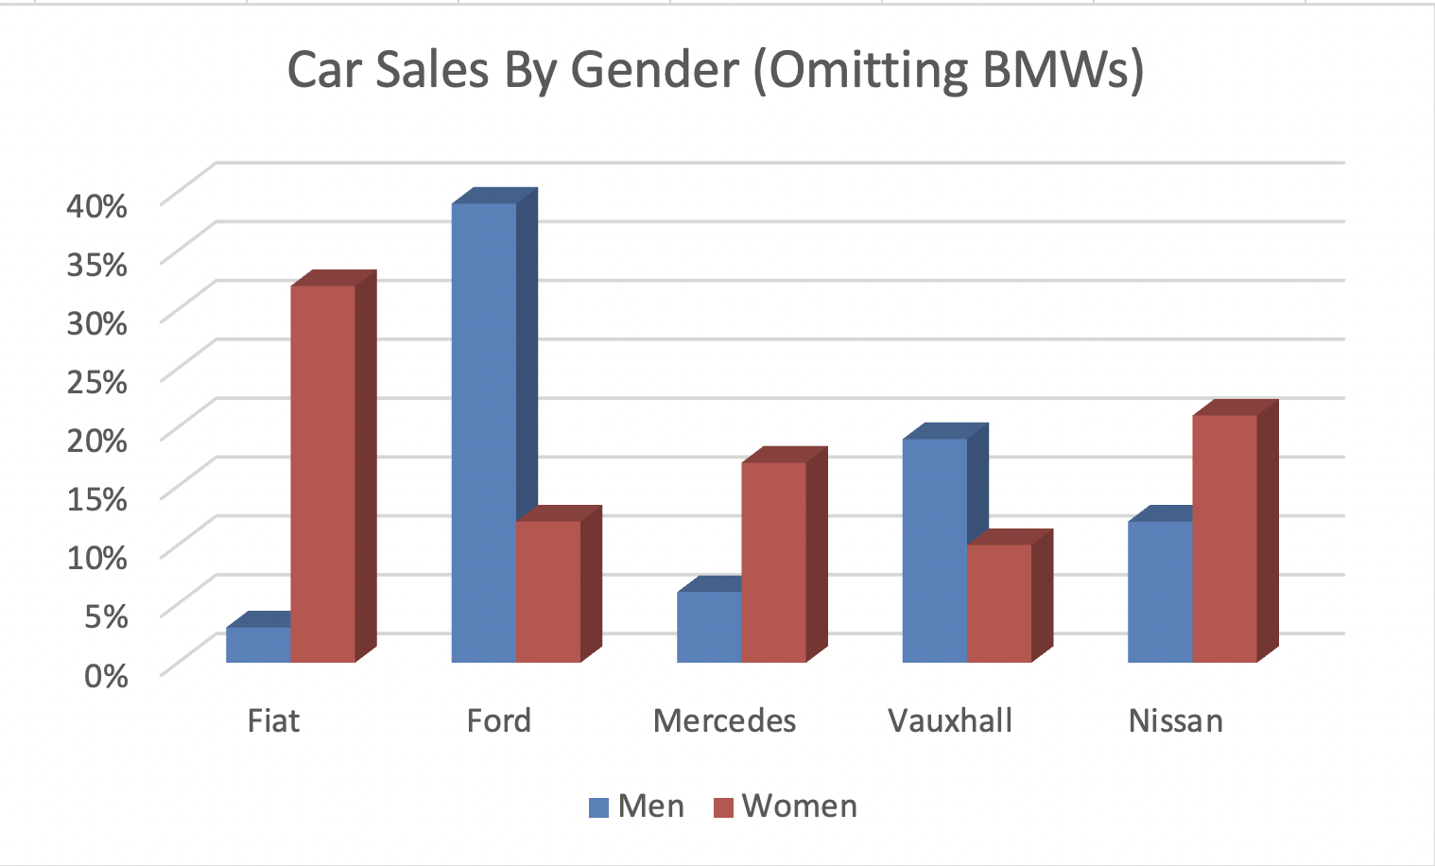

Chart 2

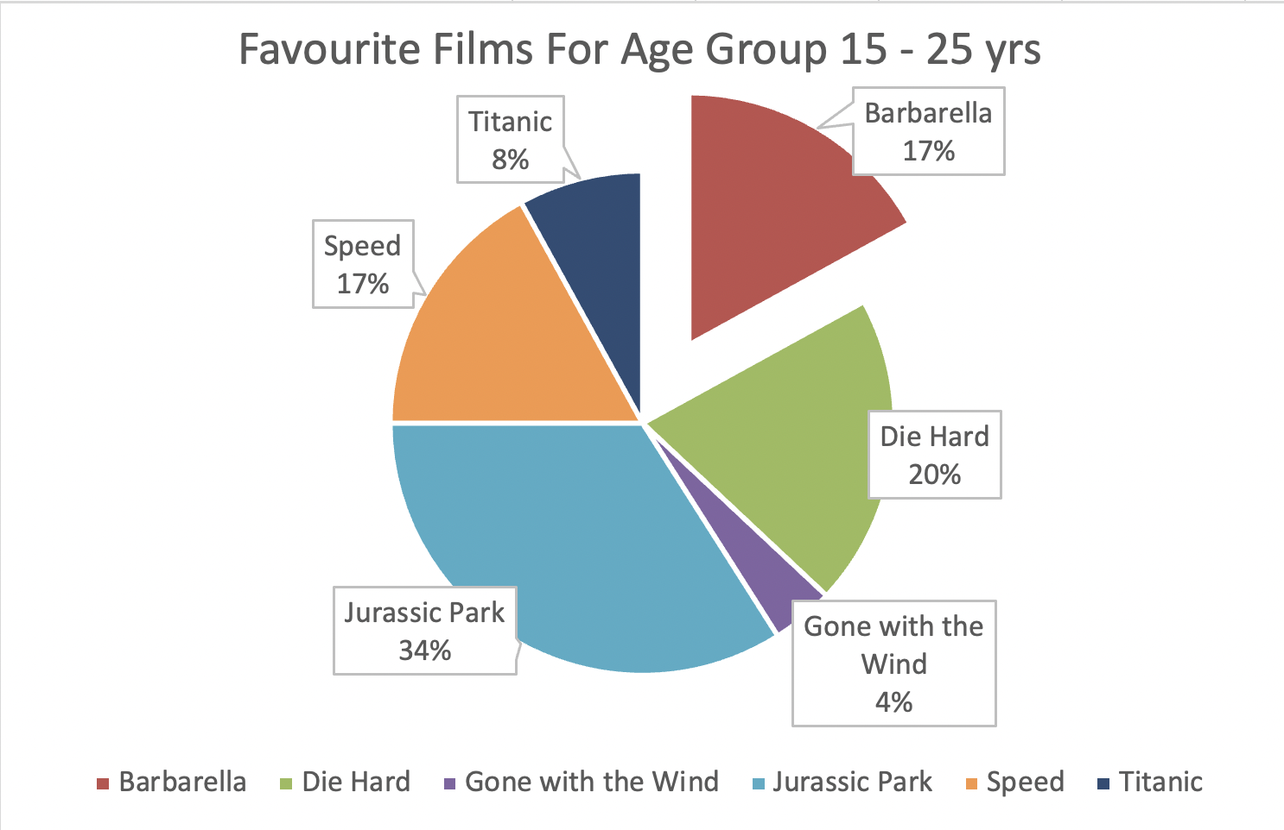

Chart 3

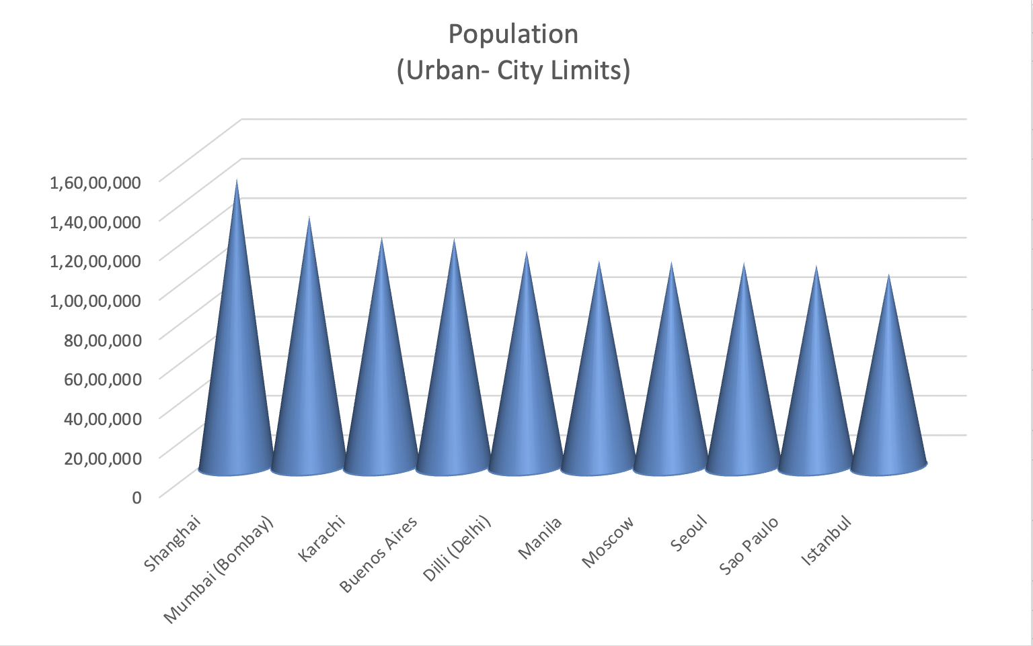

Chart 4

Chart 5

Chart 6

